Module Name: Student Management System
Test Case ID: TC_001
Tester Name: Janvi Patel
Webpage Name: Student Management System
Technology Used: Python
IDE: Visual Studio Code
Browser: Not Applicable

Scenario 1a

Scenario ID: 1a

Scenario: Open Login Page

Test Steps:

- Launch the Student Management System application in Google Chrome and navigate to the login page.

Test Input:

URL of Login Page

Expected Result:

Login page should open successfully and display username and password fields.

Actual Result:

Login page opened successfully with all required fields visible.

Status:
PASS

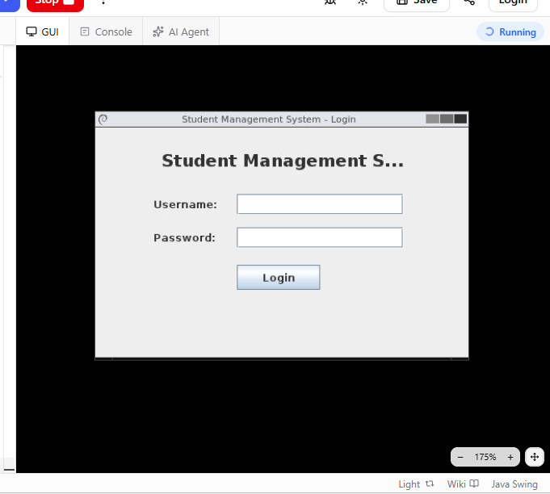

Scenario 1b

Scenario ID: 1b

Scenario: Enter Valid Username

Test Steps:

Click on username field and enter a valid registered username.

Test Input:
Admin

Expected Result:

Username should be accepted by the system without any

validation error.

Actual Result:

Username accepted successfully without any error.

Status:

PASS

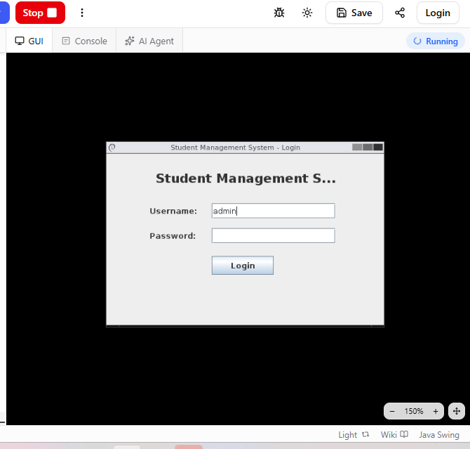

Scenario 1c

Scenario ID: 1c

Scenario: Enter Valid Password

Test Steps:

Click on password field and enter the correct password.

Test Input:
Admin123

Expected Result:

Password should be accepted and masked properly.

Actual Result:

Password accepted and displayed in masked format.

Status:

PASS

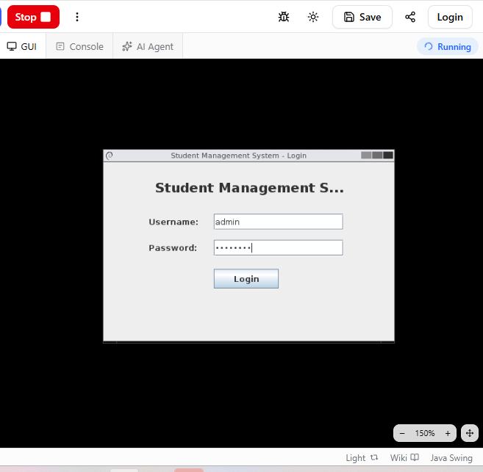

Scenario 1d

Scenario ID: 1d

Scenario: Click Login Button

Test Steps:

After entering valid credentials, click on the Login button.

Test Input:

Login Button

Expected Result:

System should authenticate the user and process the login request.

Actual Result:

System processed the login request successfully.

Status:

PASS

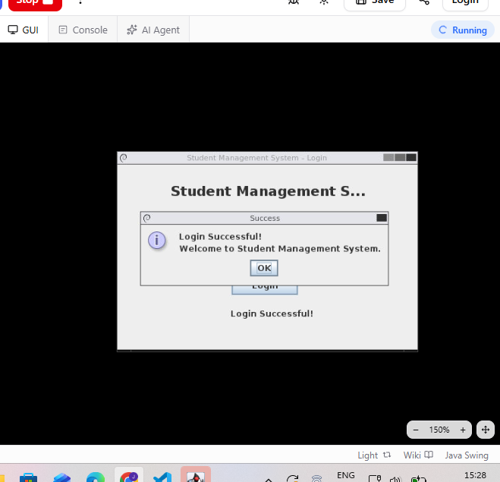

Scenario 1e

Scenario ID: 1e

Scenario: Verify Successful Login

Test Steps:

Check whether the user is redirected to the dashboard after successful authentication.

Test Input:
Valid username and password

Expected Result:

User should be redirected to the dashboard and login should be successful.

Actual Result:

User redirected to dashboard successfully.

Status:

PASS
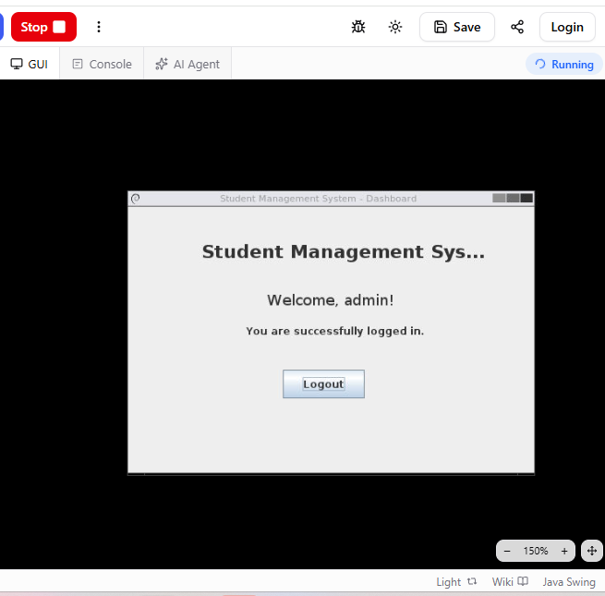

Scenario 1f

Scenario ID: 1f

Scenario: Enter Invalid Username

Test Steps:

Enter a username that is not registered in the system.

Test Input:

Wronguser

Expected Result:

System should reject the username and display an error message.

Actual Result:

System displayed invalid username message.

Status:

PASS
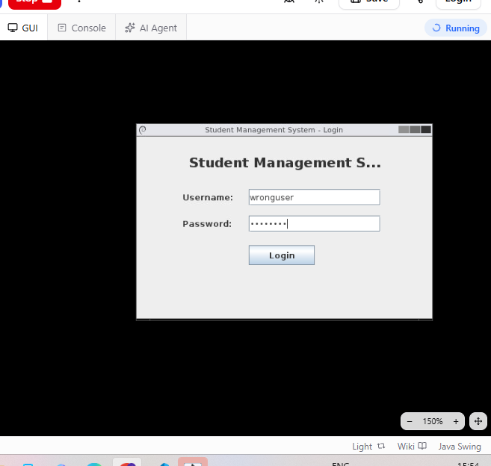

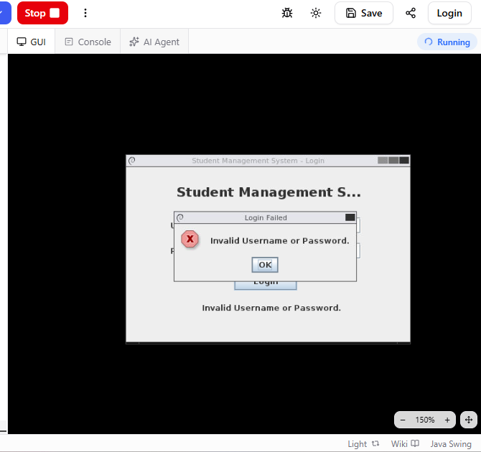

Scenario 1g

Scenario ID: 1g

Scenario: Enter Invalid Password

Test Steps:

Enter an incorrect password for a valid username.

Test Input:

Username: admin
Password: wrongpass

Expected Result:

System should reject the login attempt and show an error message.

Actual Result:
System displayed invalid password message.

Status:

PASS
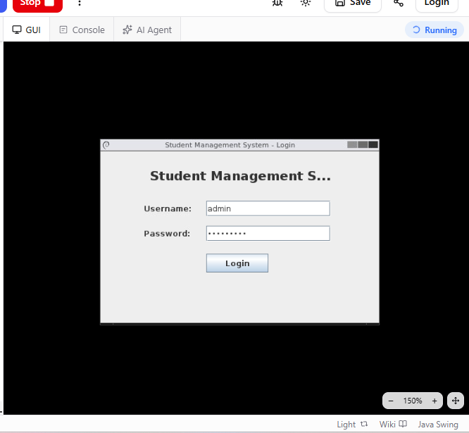

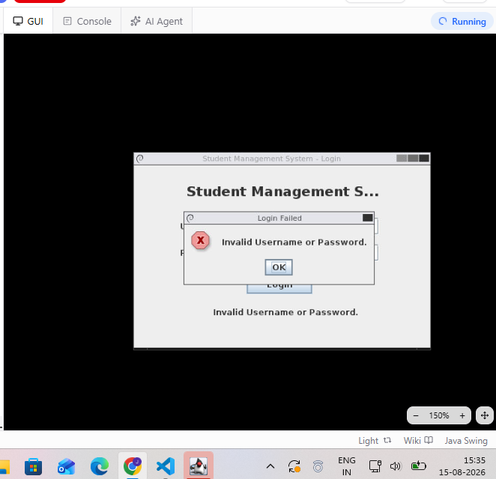

Scenario 1h

Scenario ID: 1h

Scenario: Leave Username Blank

Test Steps:

Keep the username field empty and enter a valid password.

Test Input:

Username: blank
Password: admin123

Expected Result:

System should display a validation message for username field.

Actual Result:

System displayed username required message.

Status:

PASS
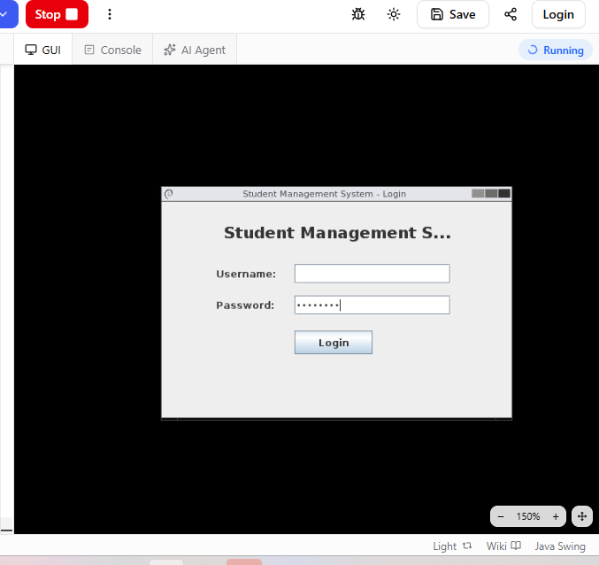

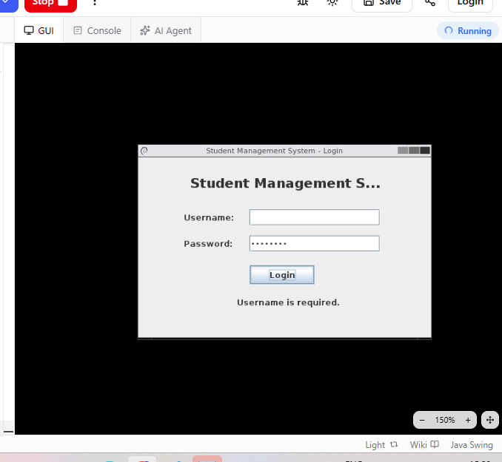

Scenario 1i

Scenario ID: 1i

Scenario: Leave Password Blank

Test Steps:

Enter a valid username and keep password field empty.

Test Input:

Username: admin, Password: blank

Expected Result:

System should display a validation message for password field.

Actual Result:

System displayed password required message.

Status:

PASS
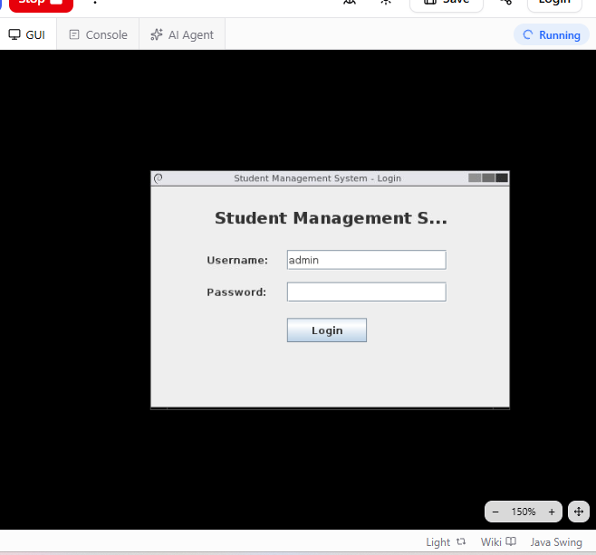

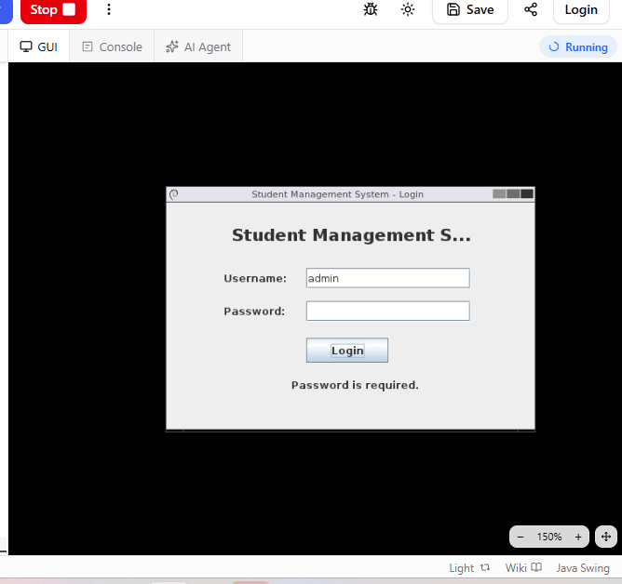

Scenario 1j

Scenario ID: 1j

Scenario: Leave Both Fields Blank

Test Steps:

Keep both username and password fields empty and click Login.

Test Input:

Username: blank, Password: blank

Expected Result:

System should display validation messages for both fields.

Actual Result:

System displayed validation messages for both fields.

Status:

PASS
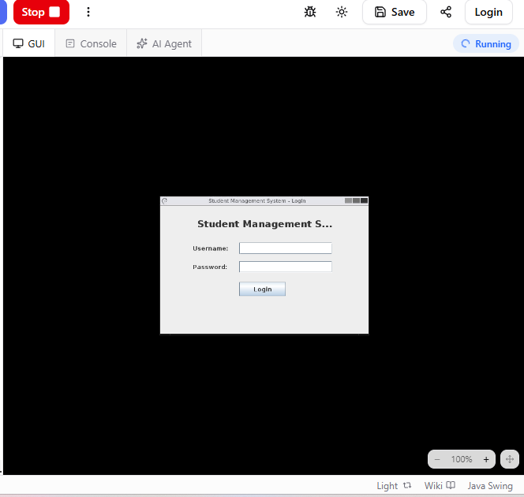

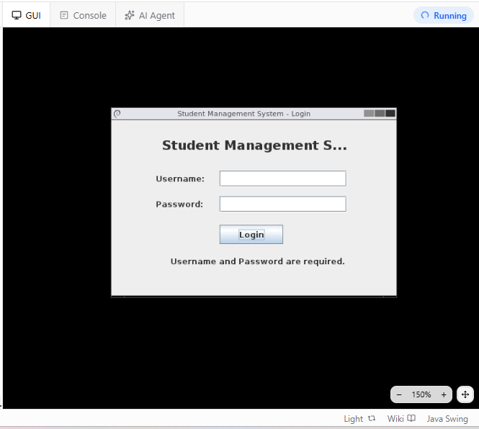

Scenario 1k

Scenario ID: 1k

Scenario: Check Case Sensitivity

Test Steps:

Enter username and password using different letter case.

Test Input:

Admin / Admin123

Expected Result:

System should not allow login if credentials are case sensitive.

Actual Result:

Login failed as expected.

Status:

PASS
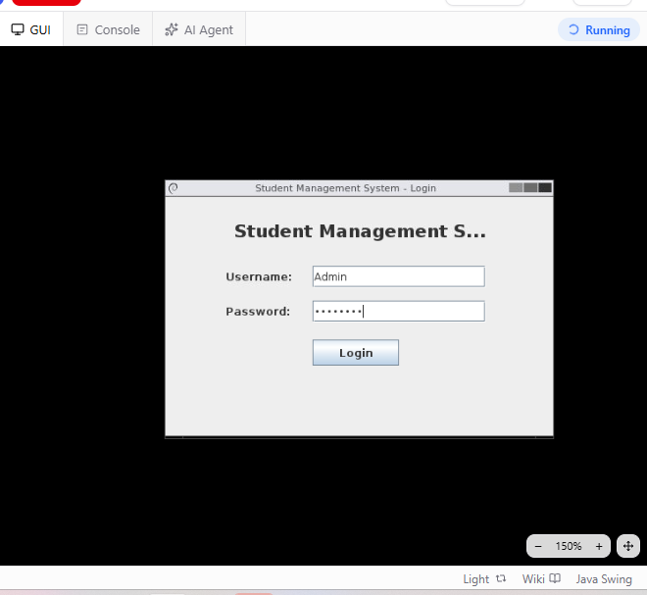

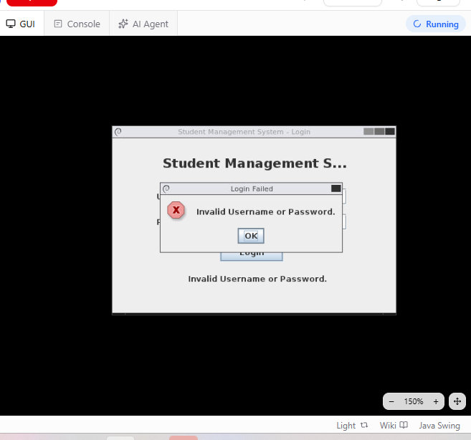

Scenario 1l

Scenario ID: 1l

Scenario: Verify Logout Functionality

Test Steps:

Login successfully and then click on the Logout button.

Test Input:

Logout Button

Expected Result:

System should terminate the session and return to login page.

Actual Result:

System returned to login page successfully.

Status:

PASS
